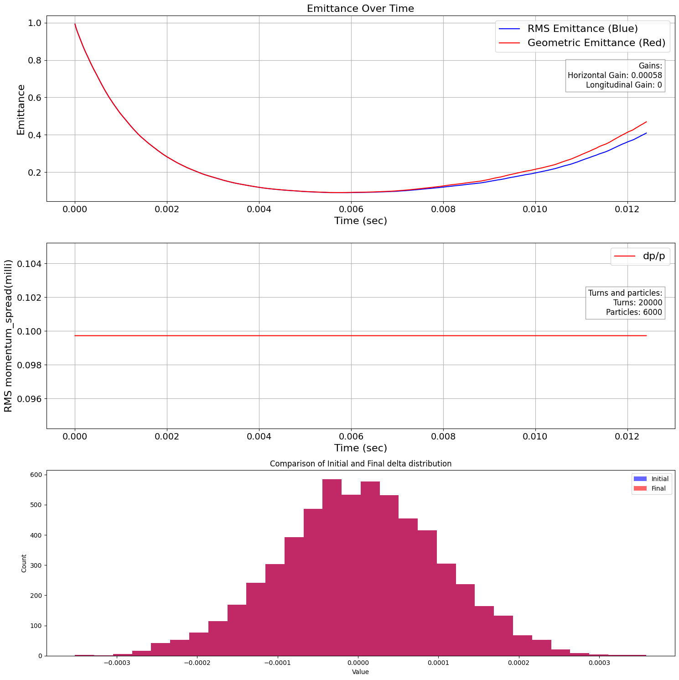
Emittance blow up …
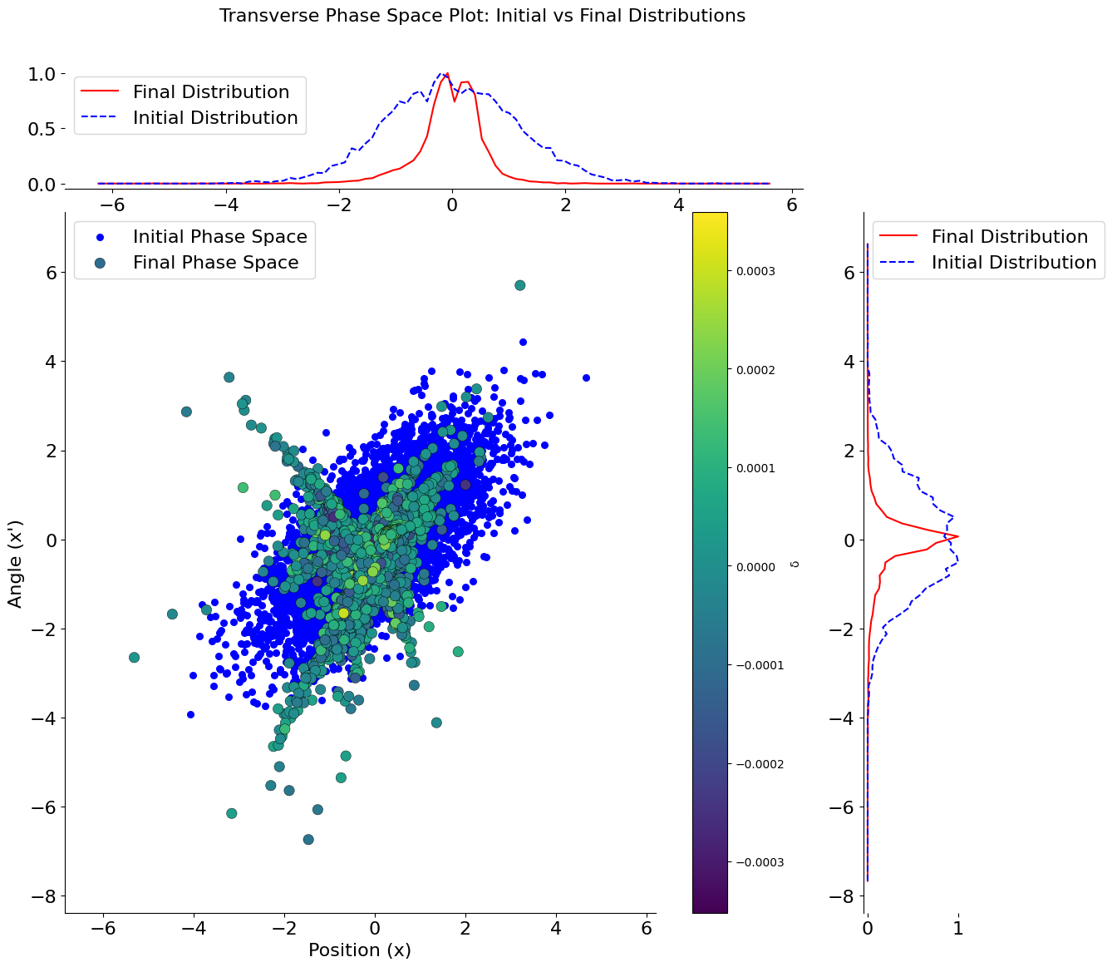

Seed a , dependence of the particles based on their δ

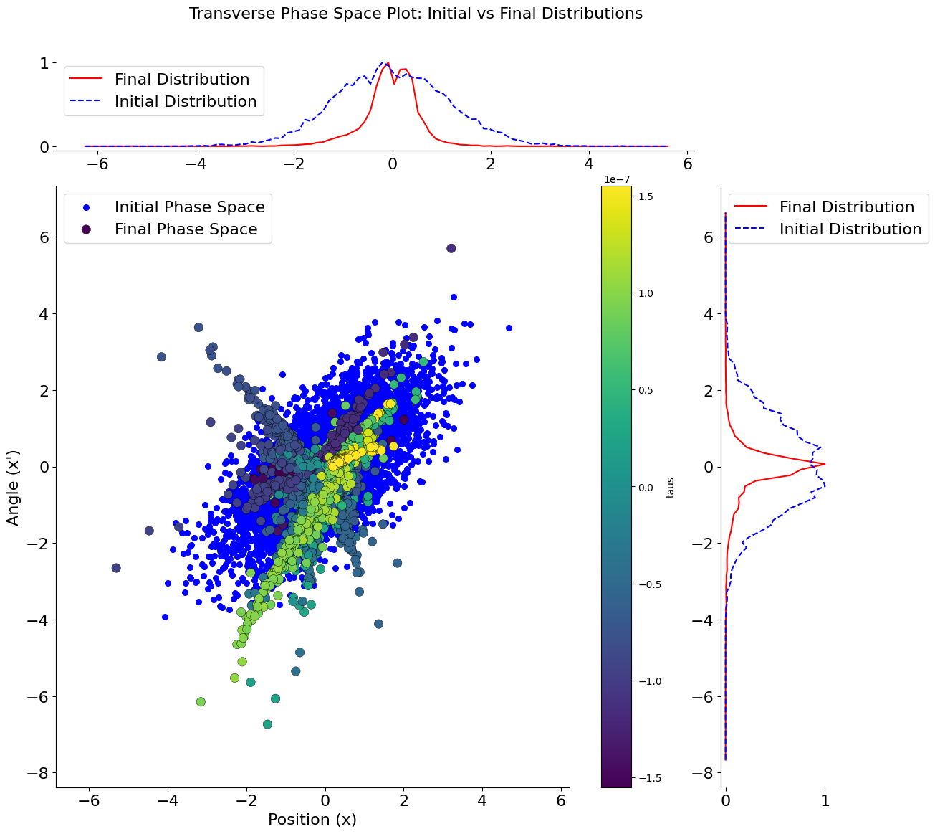

Seed a , dependence of the particles based on their taus

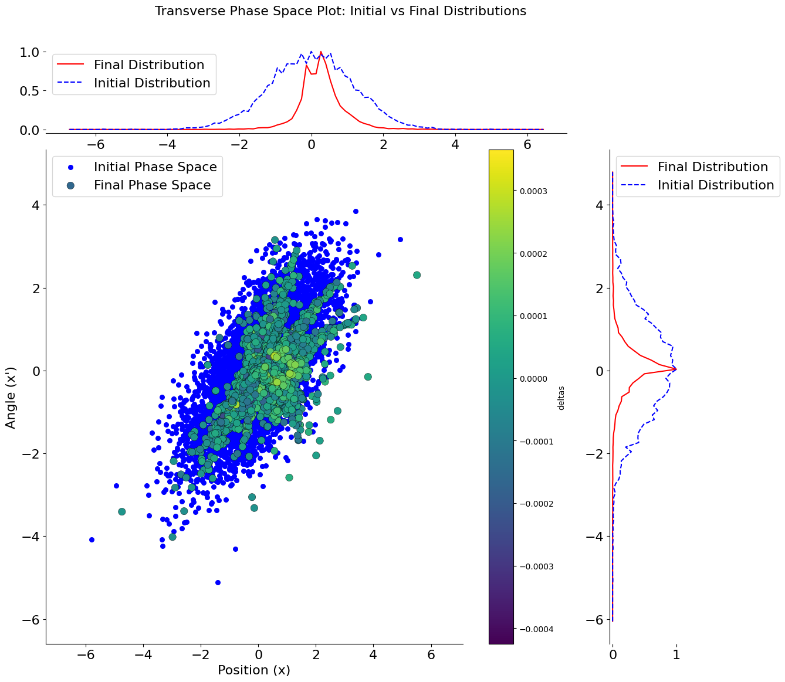

Seed b , dependence of the particles based on their δ

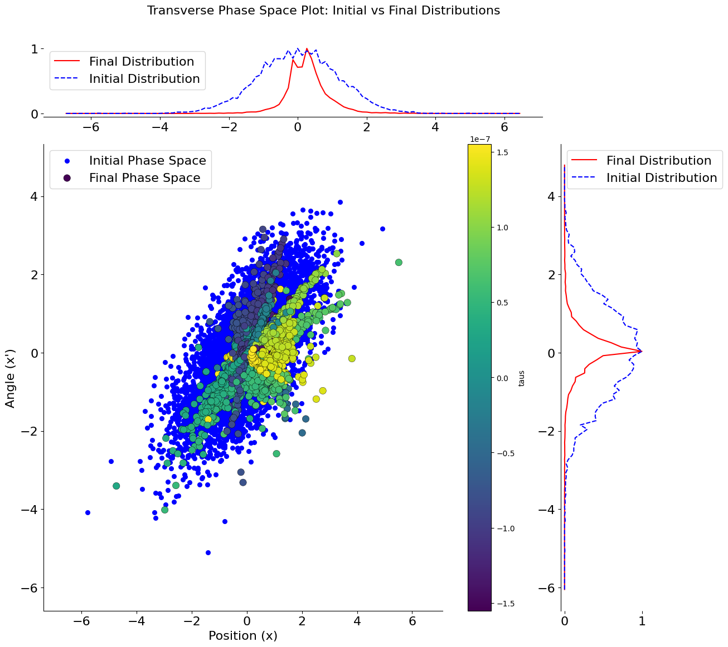

Seed b , dependence of the particles based on their taus

